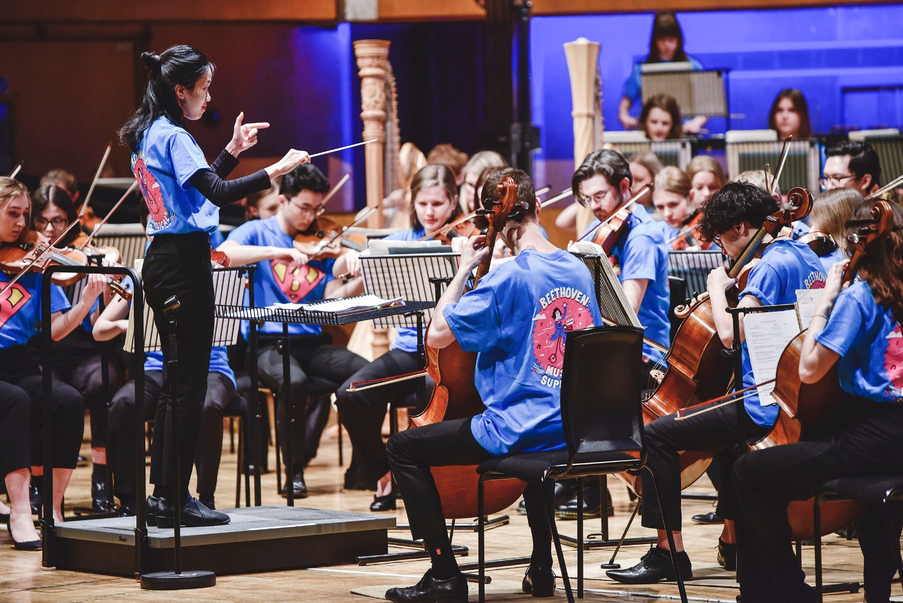
Large Print

Go and See Fund

Creative learning through the arts

September 2021

Contents
Igniting the spark… 3
Go and See: High-quality Arts Activity 3
What will we pay for? 4
How to apply 6
Deadline for applications 6
Learning from what’s happening 7
Find out more 7
Go and See application top tips: 7

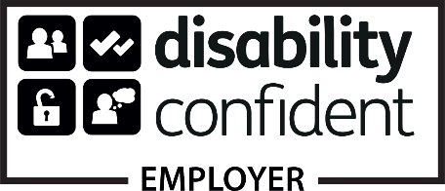
Arts Council of Wales is committed to making information available in large print, braille, audio, Easy Read and British Sign Language and will endeavour to provide information in languages other than Welsh or English on request.

Front cover: Orchestradventure! Royal Welsh College of Music & Drama (image: Kirsten Mcternan)

Igniting the spark…
Experiencing the arts can be inspiring, challenging, engaging, and fun, and has an important part to play in the learning experiences of our young people wherever in Wales, they live.
We believe that our children and young people should have the chance to be inspired and excited by the best that the arts in Wales has to offer. So, as part of the Welsh Government/Arts Council of Wales joint-funded Creative learning through the arts programme, the Go and See Fund aims to provide children and young people with opportunities to engage with unique high-quality arts and cultural experiences.
This guidance will help you decide if the Go and See Fund is right for you. It will also explain whether the activity you’re thinking about is the type of thing that we’re able to support. Finally, we tell you how to goabout making an application for funding.

Go and See: High-quality Arts Activity
Go and See is a simple scheme offering funding for straightforward visits to high-quality arts and cultural experiences. Schools can apply for small, grants of up to £1,000 to fund single visits to arts and cultural events in venues across Wales. Go and See experiences could include visits to performances and exhibitions, or visits to experience arts professionals developing and creating their work.
Go and See funding is growing in popularity and lots of schools and learners are already benefitting from high-quality arts and cultural experiences outside the school and classroom environment. You can read about some of the Go and See experiences schools and learners have been enjoying on our website

What will we pay for?
We don’t have a monopoly on good ideas. So, we don’t want to be overly prescriptive in setting out what we will and won’t fund. The important thing is that an application demonstrates how the proposed visit contributes to and enriches learning and how it offers learners something new and stimulating. We’re looking for experiences that really will try and make a difference.
Here are a few pointers on some of the things we are prepared to consider:
- Coach hire or other public transport costs. We expect you to use the most economical means of transport practicable.
• Ticket costs. We expect you to take advantage of discounts and block booking opportunities where these are available.
• Workshop costs. These must be delivered by the arts/cultural organisation as part of the visit.
• We’re able to provide up to 90% funding for approved proposals, and match funding can be either or a mix of cash and in-kind support.
Go and See is open to all maintained schools in Wales.
Unfortunately, we are unable to provide funding for:
• Capital expenditure/the purchase of equipment.
• Visits that are already scheduled and included in existing budgets. There is no guarantee of funding. Tickets or any bookings should not be committed prior to funding approval.
• Access to arts venues or events that are outside of Wales.
• Refreshments as part of the visit.
• Activity that takes place on the school site.
• Finally, we cannot fund activity that could take place without funding.
We know that for some schools the particular issues that they face will be different to others. For example, where a school is in an area of high economic disadvantage or in a very rural area with poor public transport, or where a Welsh medium school is in an area with little access to Welsh medium arts or cultural opportunities, we will look especially carefully at the case you make for funding.

How to apply
Go and See applications can only come from a school. You’ll need to complete an application form using our online application process, which can be accessed on our website here
The kind of information we ask you for at point of application is:
• An outline of the visit that you want us to fund.
• The total cost of the visit and the amount of grant you are requesting.
• How the (minimum) 10% of total visit costs will be met.
• Information on the group(s) of young people who’ll be benefitting from the visit (including pupil ages).
• Information on how the visit will support curriculum activity.
• A description of your school.
We are particularly interested in receiving applications involving schools that have not yet benefitted from Creative learning through the arts funding to date.

Deadline for applications
There is no deadline for Go and See, which means schools can apply for funding at any time. In most cases, you will normally hear within 4 working weeks whether your application has been successful or not, so we would encourage you to submit your application well in advance of the activity you wish to experience. You must apply a minimum of 5 working weeks in advance of your activity to allow for our grant making process.

Learning from what’s happening

As with all publicly funded projects it’s important that we include some monitoring and evaluation of what’s happened. This helps us to check that visits did happen. However, equally importantly, we want to learn about the best ways of bringing the arts and culture and education together to improve creative learning.

We want the programme to have a tangible legacy. So, after your visit, we’ll ask you to provide us with a short report on your experience and whether your anticipated outcomes were achieved. We will provide you with a template for this purpose. We’d also like you to include some short reviews and/or quotes from your learners.

Find out more
We know that making applications takes time and effort. We’re here to help. If you’re thinking of applying for Go and See funding, we’d be happy for you to contact us to discuss your proposal. Email us at creative.learning@arts.wales

Go and See application top tips:
• If you have received any previous funding from us, please make sure that you have returned a completion report so that your grant can be closed. We are unable to release further funding until this has happened.
• This programme is ring fenced for school aged children starting from nursery up until the age of 16. Please note that we are unable to fund post 16 education, including FE Colleges and Sixth Form.
• In competitive funding rounds priority will be given to schools that are yet to benefit from Creative learning through the arts funding.
• We cannot fund capital expenditure, e.g., purchasing equipment.
• Please include the exact date that you hope the visit will take place.
Make high-quality arts the focus of your visit. Activity must occur in arts and cultural venues and not within the school premises. Ensure you are requesting a grant of no more than 90% of the total cost of your visit and identify how you will meet the minimum 10% match funding requirement.
• We are unable to fund activity that you have already booked.

