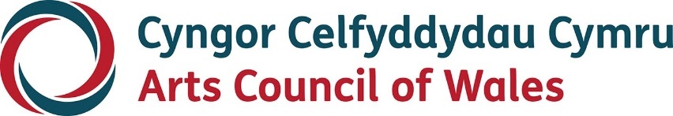

Large print

Wales in Edinburgh

Guidelines

January 2024
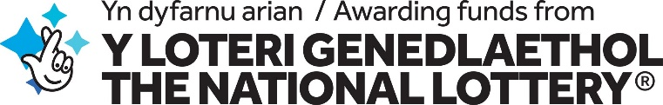
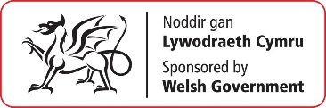
Accessibility
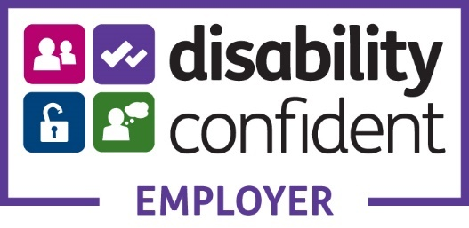
Arts Council of Wales is committed to making information available in large print, easy read, braille, audio and British Sign Language and will endeavour to provide information in languages other than Welsh or English on request. Arts Council of Wales operates an equal opportunities policy.

Contents
About 4
Your Proposal 6
Who can apply? 8
When to apply 10
Selection criteria 10
Application Process 12
Accessibility 14
What questions will I need to answer? 15
Need to get in touch? 18

About
The Wales in Edinburgh programme is a showcase fund which supports Welsh and Wales based artists to present their work on the international platform, Edinburgh Festival Fringe, in order to reach new audiences, develop sustainable relationships and enrich their practice.
The Edinburgh Festival Fringe is the world’s largest arts festival. Wales in Edinburgh is a curated showcase that promotes the highest of quality in Welsh theatre, dance, music and circus. The programme’s vision is to use the Edinburgh Festival Fringe not as a destination but a platform for our arts organisations and creative professionals to realise their international ambitions.
The Festival is attended by audiences, programmers, promoters and producers from across the UK and the World. We believe that performing arts companies and creative professionals from Wales have a unique quality that can operate on a global scale.
Delivered by Arts Council of Wales through its international team, Wales Arts International, the curated programme offers a chance for arts companies and creative professionals who feel they are ready to showcase, to develop markets, and find ways of enhancing their touring patterns outside of Wales.
Our selection process will reflect the Arts Council of Wales’ six priorities as outlined in the Investment Review: Creativity, Widening Engagement, Welsh Language, Climate Justice, Nurturing Talent, and Transformation. We care about the individual voice and personal expression of Wales, and we remain committed to excellence and to supporting bold, innovative and provocative art.
We want to see proposals from companies and creative professionals with a proven track record of creating interesting and relevant work that is ready for showcasing at the Fringe and future touring beyond Wales.
Given the extensive range of applicants and productions sizes who apply to the fund, we ask our applicants to consider this fund as a contribution towards the cost of presenting their work at the Festival. This is inclusive of venues and technical hires, access, marketing, accommodation and performances fees.
The total amount available for Wales in Edinburgh 2024 is £80,000. We would expect to fund between 4-5 applicants with strong proposals and who are showcase ready.

Your Proposal
We will be looking for a strong and compelling rationale for any Wales in Edinburgh proposal.
It is not expected that all proposals to have fully gone into full production and will accept previews and openings at the festival. However, we would expect to see a strong track record in your portfolio of work.
We expect you to show us how the production will be of the highest quality, how it will be distinctive and exciting, how it will raise your international profile and the profile of Wales, and how it has the potential to attract audiences.
It is important that the work reaches as wide an audience as possible. So we’ll want to see credible and convincing marketing and audience development approach, where all partners are working together to maximise audience in Edinburgh. We will want to understand why you’ve chosen a particular venue.
Only organisations and creative professionals based in Wales or who have an extensive record of working in Wales can apply for these awards.
The deadline for applications is 5pm 14th February 2024.
Applications will be considered by a panel of experts made up of external experts and relevant members of our team.

Who can apply?
Professional producing companies and creative professionals can apply to this scheme. You must be able to prove that your company or practice is based in Wales or you have worked extensively in Wales.
You must have:
• A track record of delivering high quality arts activity for audiences or participants.
• An Equal Opportunities Policy that’s been reviewed by your governing body within the last three years, and which complies with current legislation. If a creative professional, you must be able to show us that you have an awareness and understanding of Equal Opportunities and you reflect equality and diversity in your practice.
• A bank account in your organisation’s name that requires at least two people to authorise transactions or if a creative professional, a bank account in your legal name. For further information on bank accounts for organisations click here and for bank account information for creative professionals click here.
• If a creative practitioner, you must be over 18 and live in Wales or have worked extensively in Wales.
• If your project involves working with children, young people or vulnerable adults you must also have a Safeguarding / Child Protection Policy that’s also been reviewed by your governing body within the last three years, and which complies with current legislation. This policy must demonstrate that safeguarding issues are reflected in your day-to-day planning and operations.
• If you’re a creative professional making an application to lead activities with children, young people or vulnerable adults, you’ll need to provide written evidence that an organisational partner with appropriate safeguarding procedures in place will take on the responsibility of safeguarding for the duration of the project.
You won’t be able to apply for funding if you’re in default of any financial agreement with Arts Council of Wales.
You’ll be asked to confirm that your organisation/ you as a creative professional meet these eligibility requirements at the start of the online application process.

When to apply
The deadline for applications will be 5.00pm, 14th February 2024.
Decisions expect to be made by 20th March 2024.

Selection criteria

Delivering artistic quality
What is your production and why do you feel it should be seen at the Festival in 2024? Why is this a good time in your career or companies work for you to present at the Festival?

International ambitions
What are your international ambitions? Where would you like to take your work? What groundwork have you achieved to date in achieving your international ambitions and what areas are you looking for support?

Planning and managing a successful project
In which venue will you be presenting your work? What is the financial deal with that venue? What evidence of demand is there for your work to be presented at the festival? How will you evaluate the longer term artistic and financial benefits of performing at the Festival?

Benefiting the public
How will you promote the performing arts in Wales and the bilingual culture of Wales while presenting your work at the Festival to an international audience? How will your presence at the Festival contribute to Wales’s arts sector in the longer term?

Funding a successful project
How will you ensure the successful delivery of this project? What assumptions have you made while formulating your project budget? How realistic and achievable are your earned income projections? How will you raise any other partnership funding?

Carbon footprint
In order to build a strong, greener economy as we make progress towards decarbonisation; please tell us what progress and measures you have made and are considering within your proposal in lowering your carbon footprint and improving environmental sustainability.

Application Process
1. You’ll need to use our online portal to make an application. If you haven’t done so already, you’ll need to register for access to the portal. You can find out how to do this here.
If you’re unable to access the online form or require further assistance, please contact: grants@arts.wales
2. Complete a Wales in Edinburgh application form on our online portal.
3. Upload the following additional material in your submission:
• A proposal in response to the opportunity and the selection criteria noted above.
This can be in provided as text or audio/video format. It should be a maximum of 5 sides of A4 or 4 minutes of audio or video.
This submission should be contained in a single file (Word or pdf) and text should be no smaller than 12pt and files should not exceed 250MB.
All video and audio material must be provided as links to your website, Vimeo or YouTube. Please remember to include security information if links are password protected.
• A budget to outline how you would use the funding.
• At least two meaning letters of support endorsing your project from independent third parties.
4. After we receive your application, we’ll send you an acknowledgement. If your application is eligible, it will proceed to assessment.
5. If your application is successful, we’ll send you an award acceptance. If you’ve not been successful, we’ll write to explain why and offer an opportunity for feedback.
6. Once you’ve signed and returned your award acceptance and we’ve verified your details, we'll release 90% of the award and we’ll pay the final 10% at the end of your project.

Accessibility
If you have any access needs and are thinking of making an application, we can help to make sure that you’re supported during the application process. Please contact us our Grants and Information team at grants@arts.wales to discuss how we can help with specific access needs.
You can find out more about access support here.

What questions will I need to answer?

1. Pre-Application Checks
Pre-application checklist.

2. Contacting You
Information about who to contact in relation to the application. This will include your language preferences and bank account information.

3. Tell us about your project
Key information about your project, including its title, start and end date and basic budgetary information including access support costs.

4. Project proposal
You will need to provide a short summary in the first box. Tell us about your project, focusing on the key artistic / creative idea and your reason for doing it at this time (This text box can hold up to 100 words). We may use this information in any publicity we produce about your project.
In the second box that asks for more information about your project you should simply insert:
Wales in Edinburgh, see attached proposal, addressing the Selection Criteria information.
The attachments we need from you for the application are detailed above and should be uploaded as supporting material.

5. Artform
Information about the range of artform activity that will be part of your project.

6. Activity types
Information about the types of activity that will be part of your project.

7. Proposed targets
Information regarding your proposed project targets, including number of exhibitions, performances, workshops, and audiences/attendees.

8. Language
The impact you think this project will have on the Welsh language: Positive, Negative or Neutral

9. Project location
Tell us where your project activity will take place.

10. Project equalities information
Give us equalities monitoring information for your project.

11. Review your application
You will see all sections of your application from here. Please check and update if needed.

12. Pre-submission check
Important: once you click the 'next' button below you will not be able to edit any information provided in the previous sections.
Summary information is displayed here. To make any changes to your answers, click the 'previous' button at the bottom of the page to return to the review tab.

13. Supporting documentation
Please see the section Application Process above which details what we ask you to submit to complete the application.

14. Declaration & submit your application
Read declaration and submit your application.

Need to get in touch?
For development advice regarding your Wales in Edinburgh proposal please contact: maggie.dunning@arts.wales
Should you have any technical issues with the application form or your portal account, please contact our Grants and Information team: grants@arts.wales
There are other ways you can contact us:
Telephone: 03301 242733 (all calls charged at local rates)
Hours: 9.00am-5.00pm Monday–Thursday, 9.00am-4.30pm Friday
Tweet: @Arts_Wales_
Website: arts.wales
Instagram: @celfcymruarts

