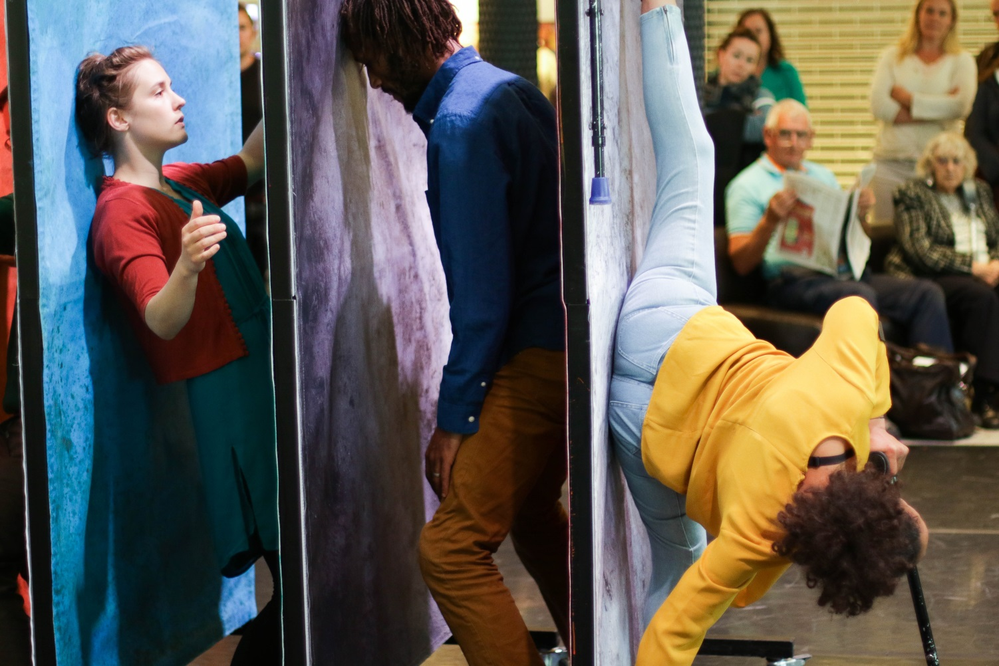
Elevator, Unity Festival 2016, Hijinx (image: Jonathan Dunn)

Arts Council of Wales

Strategic Equality Action Plan
2017 – 2021

March 2017

 | 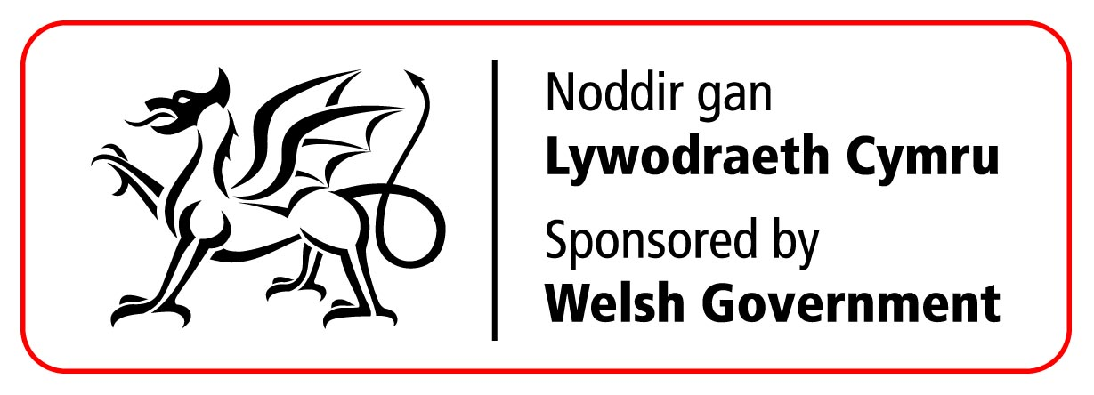

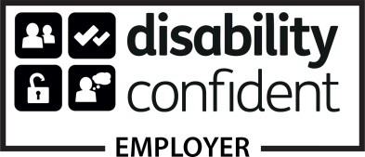 | The Arts Council of Wales is committed to making information available in large print, Braille, British Sign Language, Easy Read and on audio. We’ll endeavour to provide information in languages other than Welsh or English on request.  We implement an Equal Opportunities Policy.

Foreword

At the Arts Council of Wales we have two essential priorities – supporting excellence in the arts and broadening access to this activity. Our mission is about making the arts central to the life and well-being of the nation. Finding new ways of encouraging more people, and a wider range of people, to enjoy and take part in the best that the arts can offer is at the heart of that mission.

Working to support greater equalities across the arts in not new to the Arts Council of Wales. We published our first disability equalities strategy in 1995 and our first cultural diversity strategy in 2000. We have invested in training and support for arts organisations, encouraging them to implement successful equalities action plans, and we have provided practical help through the creation of our online Equalities Guide and Toolkit. Most recently we have launched new initiatives such as Hynt (the all-Wales disability access card scheme) and Creative Steps (a developmental programme to support artists and organisations that have encountered barriers in their efforts to access funding).

We are proud of these successes and this kind of targeted work will continue. But we need to do much more if we are to reach deeper and more widely into communities across Wales.

Our research shows that the presence of people with protected characteristics in the population as a whole is far from being matched in the activities that we are funding. The simple fact is that the arts across Wales are currently reaching a tiny number of people from protected characteristic groups. The gap is especially striking in the shockingly low number of disabled people and those from BAME backgrounds employed or represented on boards of management. This disparity is a matter of considerable concern to Council and must be ended across the lifetime of this plan.

Whether attending, taking part or working in the administration of the arts as employee or board member, we need to see a wider cross-section of the population having the opportunity to be involved in the publicly funded arts. Our goal is to go further than simply matching the overall national population statistics. The publicly funded arts should lead by example and be ambitious in its goals.

To that end, we are challenging ourselves as an organisation, our portfolio of revenue-funded companies and those we support in the wider arts sector to attach greater importance to equalities. We have set clear targets in this strategy and seeing an appropriate response to these targets will be included as a condition in our funding agreements.

The ambition to transform the arts sector’s performance in equalities will be challenging, but we are adamant that it is the right thing to do. Arts Council of Wales will respond to the challenge in a spirit of collaboration and with an openness to dialogue. However, our collective failure as a sector to match the demographic profile of the population as a whole – the very least we should expect - cannot be allowed to continue.

Our recently published Annual Equalities Report 2015/16 highlights the significant journey of change arts that we all need to make.

Ultimately, it’s about looking differently at what we’re all here to do. A concern for equalities is not just a bureaucratic requirement, a new project or an opportunity to secure funding. It is fundamentally about what we should be doing anyway – creating the kind of fair and equitable society that we all want to live in.

We want to see the arts embracing equality and celebrating difference, wherever it’s found. After all, a generous, fair-minded and dynamic society is instinctively inclusive and values and respects the creativity of all its citizens. This is the Wales we want.

Phil George
Chair, Arts Council of Wales

Equality Objective 1:

Actively engage, consult, inform, encourage, challenge ourselves and our partners
What The Evidence Says: | The information that we draw on includes the data published in our Annual Equalities Reports for 2013/14, 2014/15 and 2015/16, together with the findings of our official surveys. In addition, we have reviewed business plans and applications received from those arts organisations that were successful in becoming part of our new Arts Portfolio Wales. More recently we have reviewed the response from our Arts Portfolio Wales to the call for strategic equality plans.  Taken together, this evidence tells us that we have made some significant advances in recent years in progressing aspects of our equalities work. However, in spite of this we have fallen short of achieving our equality objectives as described in our Strategic Plan first developed in 2012. Furthermore, in some areas we have taken a step back from where we were a few years ago.  The evidence tells us that we need to do more to raise the profile of our equality objectives both within our organisation and across the wider arts sector. We made noticeable progress in our work through discussion and consultation with the people and communities we aim to reach. But our monitoring of grant applications, the responses from our Arts Portfolio and low levels of interest in staff recruitment to our own organisation suggests that we need to reconnect with these communities in a more meaningful and proactive way.  The response to our consultation on the draft Strategic Equality Plan highlighted communication as an area requiring further focus, both in terms of how we talk about the arts and equalities agenda and how we communicate with the various communities of interest. The response also highlighted the need to improve our tools for communication. We need to raise the profile of the work being delivered by ourselves, our clients and other organisations, through showcasing events and best practise. We acknowledge that the Plan is the beginning of dialogue and not the end.
Outcome: | A better engaged and informed arts sector that is confident in taking a leadership role on diversity and equalities.
What are we going  to do: | - Promote more vigorously best practice information around equality and diversity matters. We will do this through our regular communications and public events, through targeted seminars and show case events, through our equalities guidance and by publishing case studies on our  website.  - Commit to consulting on the development of all policies and programmes that will impact on people with protected characteristics both within the arts sector and those who our policies and programmes are designed to support.  - Develop the skills of our staff and draw on specific knowledge and expertise to better challenge, discuss and highlight best practice in equality and diversity with our Arts Portfolio Wales organisations.  - Create opportunities for our staff and Council to undertake continuing professional development to deepen our understanding of equality and diversity.  - Task our internal Equalities Monitoring Group with monitoring our progress in delivering these objectives and report to SLT and Council.  - Develop a shared approach to how we monitor and appraise the quality of projects and activities delivered as part of this programme.
Protected Characteristics: | Age; disability; gender reassignment; pregnancy and maternity; ethnicity; religion or belief; gender; sexual orientation, marriage and civil partnership.
Evidence Base: | Assessment of impact on protected characteristics across policy and strategy; regular monitoring reports to our Senior Leadership Team and Council, published Annual Report, case studies.
How are we going  to do it? | We will continue to discuss and consult with stakeholders on an ongoing basis via our programme of Sgwrs events and seminars.  We will use the opportunity that our National Arts Council Conference provides to raise the profile of arts and equalities.  In the first year of the plan we will develop a new approach to how we quality monitor work produced and presented that has specific relevance to our equalities agenda. We will share best practice through our website, bulletins, annual report and targeted events/showcases.  We have published an Equality Guide and an update to our document Equal Spaces, both of which provide information, advice and case studies about all aspects of equalities and the arts. We will raise the profile of these publications across the cultural sector. We will commission additional guidance materials to support the sector.  As we review our website and wider communications tools we will seek guidance to ensure these are designed to the best specifications that ensure accessibility to all.  We will continue dialogue with key partners and the sector about the progress of this plan and seek their help and advice on how we review and revise our actions moving forward.

Equality Objective 2:

Develop a workforce that better reflects the diversity of Wales
What The Evidence Says: | Our Annual Equality Reports for 2013/14, 2014/15 and 2015/16 show a fluctuating picture over the three years in terms of the numbers of people with protected characteristics employed by our Arts Portfolio organisations. Across all protected characteristics, the number of employed reduced significantly in 2014/15, but rose again in 2015/16. This pattern reflects the numbers of people employed in the Arts Portfolio generally across the three years. The key message coming out of the data is the low number of people from protected characteristics employed by the Portfolio generally, in contrast to those employed who not identified as being form these groups. The data specifically highlights this issue in relation to disabled people and people from BAME backgrounds. The statistics from our own organisation show that we still attract low numbers of applications for posts from amongst protected characteristic groups.  Individual artists who apply for funding from our Lottery scheme are asked to complete equality monitoring forms. Over the last three years we have seen a decrease in the number of forms returned, and from those received there appears to be a decrease in the number of applications received from artists with BAME backgrounds, with only a marginal increase in the number of disabled artists applying. The data also tells us that the number of protected characteristic-led groups applying for, and receiving, Lottery schemes funding remains consistently low. This is in spite of the success of our Creative Steps programme in previous years.  The feedback from our consultation exercise told us that a key step to diversifying our workforce is through Leadership. We were clearly told that we need to signal the importance of this area of work at the highest level if we are to make significant improvements and to challenge leaders within the arts sector to step up and assume greater responsibility for leading and enabling change.
Outcome: | An arts workforce that better reflects the diversity of Wales at local and national levels and is in line with the Welsh workforce statistics. An arts sector that recognises and values the contribution of people with protected characteristics in all fields, and at all levels of employment  in the arts. By 2021 disabled people will represent 12.9% of the arts workforce and at least 3.9% of the arts workforce will be from Black and Minority ethnic backgrounds.
What are we going  to do: | - Diversify the Arts Council of Wales workforce.  - Improve the knowledge and understanding of our workforce  to better equip them to support the development of a more diverse arts sector.  - Focus specifically on increasing the number of disabled people and people from BAME backgrounds employed within the arts sector.  - Champion the role of the LGBT community across the arts sector.  - Increase opportunities for disabled and BAME artists to create and present their work, via targeted support and professional development programmes, and also through prioritising support through our regular Lottery Funding.  - Work with and monitor our APW organisations to diversify their work force.
Protected  Characteristics: | Age; disability; gender reassignment; pregnancy and maternity; ethnicity; religion or belief; gender; sexual orientation, marriage and civil partnership.
Evidence Base: | Assessment of impact on protected characteristics across  policy and strategy; staff profile; complaints and grievances (public and staff); staff surveys; performance monitoring; staff appraisal; procurement policy.  Survey of Arts Wales Portfolio organisations, Arts in Wales survey. Lottery funding applications and completion reports.
How will we do it? | We will review our approach to internal recruitment and develop an action plan to improve and extend our reach. As part of a staff  development programme we will deliver a CPD and training to include an Equality/Diversity Champions strand.  We will commit to raising the profile of equalities across the work of the Council, at a Senior Leadership level and amongst our Council members.  We will review and examine the work of other bodies to learn from their successes in diversifying their workforce, and adopt or adapt these programmes for ourselves where this is appropriate.  We will continue to run the Creative Steps Business and Organisational Development Programme (launched during the first year of the Plan). This targets support for disability-led and BAME-led arts organisations – our aim is to strengthen the support network available for disabled and BAME artists across all artforms. We will also continue to ring-fence funding within our Lottery schemes to support the work of artists from amongst protected characteristic groups. We will raise the profile of the projects developed and delivered by groups supported through this programme.  We will continue to support the Unlimited Commissions Programme, in partnership with other UK Arts Councils to enhance the capacity of, and support, disabled artists and arts organisations. We will review the impact of the BAME Artists Development Programme currently being delivered by g39 and explore how to develop this programme further.  We are now a Stonewall Cymru Champion and will work with this organisation to both better understand and effectively fulfil this role. This may mean that during the life of this Plan we will develop targeted programmes.  We will require our Arts Portfolio Wales organisations, as a condition of funding, to submit satisfactory Strategic Equality Action Plans. We will expect plans to include information about how our Portfolio organisation will take steps to diversify their workforce. We will work with the Portfolio to identify, develop and deliver targeted programmes as required.  We will examine our Lottery funding criteria, guidelines and conditions of grant and revise them as required to develop a  better understanding of the make-up of the organisations we are funding, and to inform us about changes we may need to make. These will include revising our funding criteria.  We have published an Equality Guide and an update to our document Equal Spaces, both of which provide information, advice and case studies about all aspects of equalities and the  arts. We will raise the profile of these publications across the cultural sector and commission further guidance as required.

Equality Objective 3:

Improve representation in the governance of arts organisations
What The Evidence Says: | Our 2014/15 annual equality report told us that there were 764 members of management boards/governing bodies across our portfolio of funded organisations. Of these only 25 were reported as being disabled people - a reduction of 10.7% on the previous year - and only 11 from a BAME background. 34 reported being from the LGBT community and 386 were aged 50+  Our 2015/16 report shows a further decline in the numbers with only 17 disabled people and 9 from a BAME background represented on the Management Boards of 69 organisations. The number of people from the LGBT community is also reported to have decreased from 34 to 22.  The data serves to highlight one of the key issues that emerged from our consultation on the draft Plan, that of Leadership in the arts sector. Concerns were raised about the apparently low profile given to the equalities agenda amongst significant arts organisations, arts leaders including ourselves.
Outcome: | Representation on the Boards/Governing Bodies of our leading arts organisations that better reflects the diversity of Wales at local and national levels. By 2021 we will have increased the number of disabled people on boards of management of our arts organisations to at least 12.9% and the number of people from Black and minority ethnic backgrounds to at least 3.9%.
What are we Going  to Do: | - Include equality and diversity awareness in our Arts Portfolio Wales Board Development Programme  - Require and support our Arts Portfolio Wales organisations to diversify their boards and monitor progress through annual Strategic Equality Action Plans  - Revise our Lottery funding criteria to ensure that grant recipients include the promotion of equality and diversity within their work, and within their own organisation.  - Identify and share best practice case studies  - Devise a programme around Leadership in the arts with a focus on diversity.  - In year 1, prioritise progressing this area of our strategic equality plan
Protected  Characteristics: | Age; disability; gender reassignment; pregnancy and maternity; ethnicity; religion or belief; gender; sexual orientation
Evidence Base: | Assessment of impact on protected characteristics across policy and strategy; staff profile; complaints and grievances (public and staff); staff surveys; performance monitoring; staff appraisal; procurement policy.  Survey of Arts Wales Portfolio organisations, Arts in Wales survey,  Reports from our Lottery funding schemes.
How we will do it? | We will require our Arts Portfolio Wales organisations, as a condition of funding, to submit satisfactory Strategic Equality Action Plans. We will expect plans to include information about how our Portfolio organisation will take steps to diversify their boards of management. We will work with the Portfolio to identify, develop and deliver targeted programmes as required.  Our Board Development Programme and new Resilience Scheme will include specific elements to support organisations in identifying actions to diversify their Boards.  We will examine our Lottery funding criteria, guidelines and conditions of grant and revise as required to develop a better understanding of the make-up of the organisations we are funding and to inform us about changes we may need to make.  We have published an Equality Guide and an update to our document Equal Spaces. Both documents, which provide information, advice and case studies about all aspects of equalities and the arts. We will raise the profile of these publications across the cultural sector and commission further guidance as required.  Work in partnership with other bodies to develop a leadership programme around arts and equalities.

Equality Objective 4:

Increase the diversity of Arts audiences
What The Evidence Says: | Our Arts Portfolio Wales surveys for the three years from 2013/14 to 2015/16 show a fluctuating pattern in relation to attendances at events targeted at people from protected characteristic groups. Compared to the previous year, the data from 2014/15 showed that whilst there had been an increase in the number of events targeted at disabled people, there was a decrease in the numbers of disabled people attending. However, the data from 2015/16 shows an increase in both the number of targeted events and the numbers of disabled people attending. Over the three years the percentage of attendances by disabled people went from 14.3% to 8.0% to 19.7%  A similar picture emerges in relation to people from BAME backgrounds – an increase in the number of events but a decrease in attendances. The number of attendances by people from BAME backgrounds to targeted events went from 7.8% in 2013/14 to 4.7% in 2014/15 and 6.9% in 2015/16.  This data provides us with a picture of trends amongst our Arts Portfolio clients and the response to the consultation suggested that our Plan focusses too heavily on this group of organisations. Data from our last Arts in Wales survey supports the need for us to focus on these areas of low take up and in addition to working with our Portfolio clients, who receive the largest proportion of arts funding in Wales, we recognise that we need to work with the wider arts sector to achieve significant change.  Targeted sessions and attendance numbers across other areas of the protected characteristics vary considerably and from year to year suggesting a trend of varying patterns of targeted programmes. We need to look at how we capture data from across the wider programme of arts activity to give us a more comprehensive picture of patterns and trends and to help us identify where we need to focus our resources.
Outcome: | Arts programmes and events are consistently accessible and relevant to, and enjoyed by, diverse audiences. Our aim will be to increase the number of disabled people attending events by an additional 12.9%  and the number of people from Black and minority ethnic backgrounds by at least 3.9%
What We Are Going  To Do: | - Initiate and implement targeted programmes which will increase the number of disabled people attending arts events across Wales.  - Initiate and implement targeted programmes which will increase the number of people from BAME backgrounds attending arts events.  - Initiate and implement targeted programmes which will increase the number of older people attending arts events.  - Ensure, through our Lottery awards and funding agreements, an increasing number of arts events and performances are accessible to a range of diverse audiences.  - Ensure that our Arts Wales Portfolio is proactively mainstreaming opportunities for people with protected characteristics to access their work, and monitoring the diversity of its audiences.  - Agree and set targets for increasing attendance.
Protected  Characteristics: | Age; disability; gender reassignment; pregnancy and maternity; ethnicity; religion or belief; gender; sexual orientation.
Evidence Base: | Assessment of impact on protected characteristics across policy and strategy; Audience Insight and evidence from Hynt, Arts Portfolio Wales Survey, evaluation and monitoring of programmes, Arts Portfolio Wales equality plans, monitoring reports from our Lottery funding schemes, publication of infographics showing key data.
How will we do it? | We will continue to deliver Hynt, our disability card scheme for arts venues across Wales. We will also explore the potential roll-out of this scheme across the arts sector. We will monitor the impact of the scheme on audiences in Wales through our Audiences Insight marketing and audience development project.  Our funding for Production and Touring contains a condition of grant around accessible performances and we will monitor the impact of this to help inform future actions.  We will explore the potential for targeted support to encourage joint initiatives between inclusive production companies and theatres/arts centres, to produce touring work which firmly places equalities at its heart.  Our current strategy for Capital identifies the need to address access issues in our arts venues. So far, there has been little take-up of the scheme. We will re-visit this taking account of the information we receive through our Arts Portfolio Wales Strategic Equality Action Plans.  We will require our Arts Portfolio Wales organisations to submit Strategic Equality Action Plans as a condition of funding. This will enable us to be better informed about a range of issues. These include:  - the current state of play in relation to equality and employment in the arts  - the work our portfolio is intending to carry out to address the issues they have identified  - the work we need to undertake to support the portfolio  We will monitor the delivery of the Portfolio Action Plans and develop and deliver targeted programmes as required. We will include specific conditions in funding agreements with the Portfolio as required.  We will examine our Lottery funding criteria, guidelines and conditions of grant and revise these as necessary. Through our funding surgeries, we will target communities and individuals from amongst groups with protected characteristics to ensure that appropriate and relevant information is available. We will also monitor and report on the attendance at these surgeries.  We have published an Equality Guide and an update to our document Equal Spaces, both of which provide information, advice and case studies about all aspects of equalities and the arts. We will promote the profile of these publications across the cultural sector and commission further guidance.
Equality Objective 5:

Increase the diversity of arts participants
What The Evidence Says: | Our Arts Portfolio Wales survey for the three years from 2014/14 to 2015/16 shows a fluctuating picture in relation to participatory sessions for protected characteristic groups.  The data tells us that there was a percentage drop in the number of disabled people participating in targeted sessions from 2013/14 to 2014/15 (from 10.4% to 9.7%) but a slight rise in 2015/15 (11.6%).  The data for people from BAME communities participating in targeted sessions is more worrying. This shows that in 2013/14 of all targeted events people from BAME communities accounted for only 1.5% of attendences. This rose to 4.1% in 2014/15 and dropped to 2.5% in 2015/16. The number of targeted sessions for people from BAME people is also very low at between 0.4 and 0.6%.  Targeted sessions and participation numbers across other areas of the protected characteristics vary considerably and from year to year suggesting a trend of varying patterns of targeted programmes. As with audiences numbers we need to look at how we capture data from across the wider programme of arts activity to give us a more comprehensive picture of patterns and trends and to help us identify where we need to focus our resources.
Outcome: | Participatory arts programmes and events are consistently accessible, relevant to and enjoyed by all. Our aim will be to increase the number of disabled people participating in the arts by an additional 12.9% and the number of people from Black and minority ethnic backgrounds by at least 3.9%
What We Are Going  To Do: | - Initiate and implement targeted programmes which will increase the number of disabled people participating in arts activities across Wales.  - Initiate and implement targeted programmes which will increase the number of people from BME backgrounds participating in arts activities across Wales.  - Initiate and implement targeted programmes which will increase the number of older people participating in arts activities across Wales.  - Initiate and implement targeted programmes which will increase the number of children, young people and families participating in the arts, particularly from amongst our most deprived communities.  - Ensure that our Arts Wales Portfolio is proactively mainstreaming opportunities for people with protected characteristics to access their work, and monitoring the diversity of its participants.
Protected  Characteristics: | Age; disability; gender reassignment; pregnancy and maternity; ethnicity; religion or belief; gender; sexual orientation.
Evidence Base: | Assessment of impact on protected characteristics across policy and strategy; Audience Insight, Arts Portfolio Wales Survey, evaluation and monitoring of programmes, Arts Portfolio Wales equality plans, monitoring reports from our Lottery funding scheme, infographics.
How will we do it? | We will continue to deliver our current targeted programmes and evaluate their impact. This will help to inform future developments. Current programmes include: Creative Learning through the Arts a joint plan targeting children and young people, with the Welsh Government; cARTrefu Cymru – a joint project with Age Cymru and the Baring Foundation which aims to reach older people living in residential homes.  One of our key objectives from 2016 onwards is to develop a major strategy for Arts and Health in Wales. Our scoping work to date has indicated that arts and mental health is likely to be a key feature of this strategy which will require specific actions and programmes.  Our current strategy for Capital funding includes a strand which aims to address access issues in our arts venues. There has been little take up of the scheme to date and we will re-visit this taking account of the information we receive through our Arts Portfolio Wales Strategic Equality Action Plans.  We will require our Arts Portfolio Wales organisations to submit Strategic Equality Action Plans, as a condition of funding. This will better inform us of the current state of play in relation to equality and employment in the arts, the work our portfolio is intending to carry out to address the issues they have identified and the work we need to undertake to support the portfolio. We will monitor the delivery of the Portfolio Action Plans and develop and deliver targeted programmes as required. We will include specific conditions in funding agreements with the Portfolio as required.  We will examine our Lottery funding criteria, guidelines and conditions of grant and revise as required. Through our funding surgeries, we will target communities and individuals from amongst groups with protected characteristics to ensure that appropriate and relevant information is available. We will also monitor and report on the attendance at these surgeries.  We have published an Equality Guide and an update to our document Equal Spaces, both of which provide information, advice and case studies about all aspects of equalities and the arts. We will raise the profile of these publications across the cultural sector and commission further guidance as required.  We are in the early stages of developing a partnership with the Gypsy, Roma, Traveller community in Wales and anticipate the emergence of a targeted project in year 2 of this plan.

