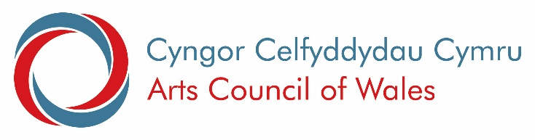
Easy Read

Funding the future of arts in Wales
Response Form

This document was written by the Arts Council. It is an easy read version of the questions from ‘2022 Investment Review: Funding the future of arts in Wales’.

July 2022

Introduction
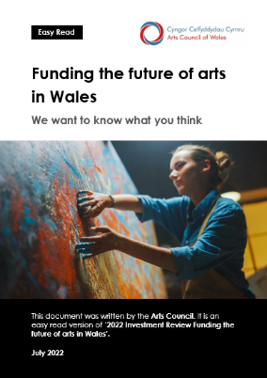

Please read the main document, and then answer these questions.

Contact us if you have any questions by e-mail at: investmentreview@arts.wales.

Please send your answers to us by 5pm, 10 October 2022 to:

E-mail: investmentreview@arts.wales

Questions

Changing how we work
Please read pages 4 to 7 of the main document.
Question 1:
Do you agree that we need to do things differently? And what else would you like to change?

Question 2:

We have talked about changes that have taken place in Wales. What else do you think is important?

What will change

Please read pages 8 and 9 of the main document.

Question 3:
There are 3 parts to this question:
- Do you think our 6 priorities are important to the arts and Wales?
- Do you think any should be changed?
- Are there any we have missed?

Changing how we fund art

Question 4:

Please read pages 10 to 13.
There are 3 parts to this question:

- Do you think 1 application form for everyone is fair?
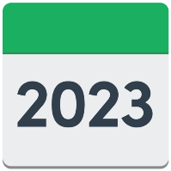
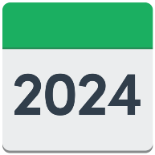
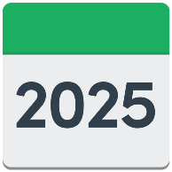
- Do you think it is a good idea to offer funding for 3 years?
- Do you think there could be any problems with this?

Question 5:
There are 2 parts to this question:
- Do you think we need to ask organisations for any more information?

- Do you think there is anything we should not be asking?

What we want to do for you

Please read pages 12 and 13 of the main document.

Question 6:
Do you think what we are offering organisations is clear? And is there anything else we should be offering?

How organisations can apply for funding

Please read pages 14 to 16 of the main document.
Question 7:
Do you understand what information we will need and when we will need it? And are there any comments you would like to make?

Assessing applications

Please read page 16 of the main document.
Question 8:
Do you understand how we check applications? And do you have any other comments?

How we will assess applications

Please read page 16 of the main document.

Question 9:
Do you understand what information you will need to apply? And do you have any other comments about this?

Funding

Please read page 17 of the main document.

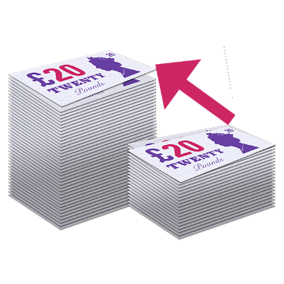
Question 10:
Do you understand our section on funding? And are there any comments you would like to add here?

Your responsibility

Please read page 18 of the main document.
Question 11:
Do you understand what we want to do in this section? Are there any comments you would like to add?

Who can apply for funding?

Please read page 19 of the main document.

Question 12:

Do you understand which types of organisations can apply for funding? And would you change any of these and why

Appeals

Please read page 20 of the main document.

Question 13:
Do you have any comments on appeals?

Thank you

Thank you for answering these questions.

Please contact us if you have any questions by e-mail at: investmentreview@arts.wales.

Please send your answers to us by 5pm, 10 October 2022.

