Large print

Arts Council of Wales

Safeguarding Policy

September 2022

Accessibility
Arts Council of Wales is committed to making information available in large print, easy read, braille, audio and British Sign Language and will endeavour to provide information in languages other than Welsh or English on request.
We operate an Equal Opportunities Recruitment Policy and welcome applications from all sections of the community in Welsh or English. There will be no delays in correspondence due to language preference.
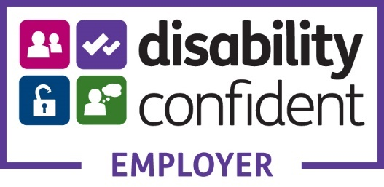

Arts Council of Wales Safeguarding Policy
The Arts Council of Wales is the official body that funds and develops the arts in Wales. We are an independent charity established by Royal Charter in 1994. We’re ambitious for the arts in Wales and our strategy is to build a place where we can find, nurture and share the best talent and provide opportunities for people in all parts of Wales to experience the arts.
The funding (money) we distribute comes from both the Welsh Government and The National Lottery. Most of our funding goes to artists and arts organisations carrying out programmes of work across Wales. Sometimes we also run our own projects, especially where these explore new areas of arts activity, or help us to persuade other organisations to take an interest in the arts.
As a public body, it’s very important that everything we do is open and accessible to all.

The purpose of this policy statement is:
- to protect children, young people and vulnerable adults who engage in activities delivered or supported by us from harm.
- to provide staff with the overarching principles and procedures that guide our approach to safeguarding.
This policy applies to anyone working on behalf of the Arts Council of Wales, including senior managers and the board of trustees, paid staff, volunteers, sessional workers, agency staff and students.

Legal framework
This policy has been drawn up on the basis of legislation, policy and guidance that seeks to protect children and vulnerable adults in Wales. A summary of the key legislation and guidance is available from www.nspcc.org.uk/childprotection.

Supporting documents
This policy statement should be read alongside our organisational policies, procedures, guidance and other related documents:
- Our safeguarding procedures
- Supporting documents
- role description for the designated safeguarding officer
We believe that:
- children, young people and vulnerable adults should never experience abuse of any kind
- we have a responsibility to promote the welfare of all children, young people and vulnerable adults, to keep them safe and to practise in a way that protects them.

We recognise that:
- the welfare of children, young people and vulnerable adults is paramount in all the work we do and in all the decisions we take.
- working in partnership with children, young people, their parents, carers and other agencies is essential in promoting young people’s welfare
- all children, regardless of age, disability, gender reassignment, race, religion or belief, sex, or sexual orientation have an equal right to protection from all types of harm or abuse
- some children are additionally vulnerable because of the impact of previous experiences, their level of dependency, communication needs or other issues
- extra safeguards may be needed to keep children who are additionally vulnerable safe from abuse.
We will seek to keep children, young people and vulnerable adults safe by:
- valuing, listening to and respecting them
- appointing a nominated child protection lead for children and young people, a deputy and a lead trustee/board member for safeguarding
- adopting child protection and safeguarding best practice through our policies, procedures and code of conduct for staff and volunteers
- developing and implementing an effective online safety policy and related procedures
- providing effective management for staff and volunteers through supervision, support, training and quality assurance measures so that all staff and volunteers know about and follow our policies, procedures and behaviour codes confidently and competently
- recruiting and selecting staff and volunteers safely, ensuring all necessary checks are made
- recording and storing and using information professionally and securely, in line with data protection legislation and guidance
- sharing information about safeguarding and good practice with the sector we are here to support
- making sure that children, young people, vulnerable adults and their families know where to go for help if they have a concern
- using our safeguarding and child protection procedures to share concerns and relevant information with agencies who need to know, and involving children, young people, parents, families and carers appropriately
- using our procedures to manage any allegations against staff and volunteers appropriately
- creating and maintaining an anti-bullying environment and ensuring that we have a policy and procedure to help us deal effectively with any bullying that does arise
- ensuring that we have effective complaints and whistleblowing measures in place
- ensuring that we provide a safe physical environment for our children, young people, staff and volunteers, by applying health and safety measures in accordance with the law and regulatory guidance
- building a safeguarding culture where staff and volunteers, children, young people and their families, treat each other with respect and are comfortable about sharing concerns.

Contact details

Nominated child protection lead
Name: Sian James
Phone/email: 029 20441351 sian.james@arts.wales

Deputy child protection lead(s)
Name(s): Janine Reynolds
Phone/email: 029 20441339 janine.reynolds@arts.wales

Research and resources

Trustee/Senior lead for safeguarding and child protection
Name: Diane Hebb
Phone/email: diane.hebb@arts.wales
NSPCC Helpline: 0808 800 5000
We are committed to reviewing our policy and good practice annually.
This policy was last reviewed on: ……31 August 2022
Signed: 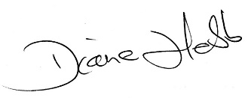
Date: 2 September 2022

