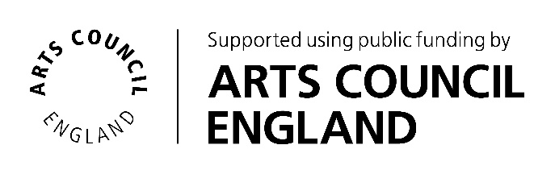
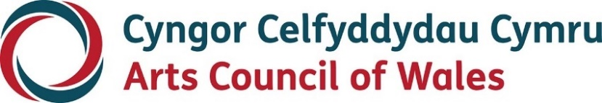

Large print

UK Access Champion

Expressions of Interest

September 2022

Accessibility
Arts Council of Wales is committed to making information available in large print, easy read, braille and audio and British Sign Language and will endeavour to provide information in languages other than Welsh or English on request.
We operate an Equal Opportunities Recruitment Policy and welcome applications from all sections of the community in Welsh or English. There will be no delays in correspondence due to language preference.
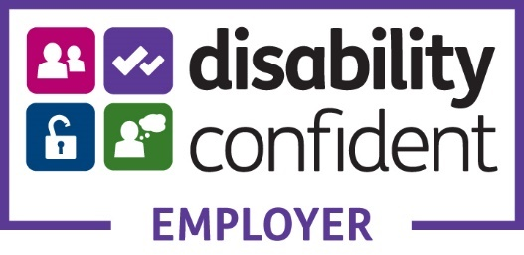
Contents
About the Access Scheme 5
Background 5
What will the scheme do? 6
An Access Champion for the Scheme 8
What would you be doing as the Access Champion? 8
What are the skills and expertise you’d bring to the role? 9
Are you interested in supporting us to achieve our goal? 11
How to apply 12
Assessment 13
Interviews 14
Any Questions? 14

About the Access Scheme

Background
The Arts Council of Wales (ACW), Arts Council England (ACE), Arts Council of Northern Ireland (ACNI), the British Film Institute (BFI) and Creative Scotland (CS) have come together to develop plans for a UK wide access scheme for Deaf, disabled and neurodivergent audiences attending arts and cultural events. This includes everything from Theatre shows, to Gallery Exhibitions and Film showings.
A 2020 feasibility study found overwhelming support from both Deaf and disabled people for a UK wide scheme, as well as arts and cultural organisations.
We are currently conducting further research and development by consulting with a wide range of people who have access needs when attending events. This will consider the impact of the pandemic and dig deeper into what people would want from such a scheme. We have also commissioned a technical feasibility study looking into the system requirements and user journey.
This project is, and will continue to be, disabled-led and inclusive, reflecting the needs of the groups we seek to serve.

What will the scheme do?
Nothing is finalised yet, as we are still carrying out the research phase, but the scheme will build on research undertaken and the learning gained from existing initiatives such as the Hynt card in Wales.
It will also drive forward our shared aims around addressing the issues highlighted through the #WeShallNotBeRemoved campaign and the seven inclusive principles.
Potential features of the UK wide scheme that are being explored include:
• An online access membership scheme and website, where members can find information about accessible performances, venues and sign up to register their access needs.
• The ability to integrate with the major ticket booking systems, allowing users to book tickets online, and for participating organisations to automatically receive the access requirements of scheme members.
• Data and analysis for the arts sector on engagement trends for Deaf, disabled and neurodivergent audiences, which will inform the sector to help grow audiences and drive the provision of improved access.
• A training and support hub for organisations, featuring resources on how to develop best practice in delivering accessible programming, events and spaces.
• An accreditation programme for participating venues.
The Access Scheme Advisory Group (ASAG) will support the development of this scheme by bringing personal and sector expertise to the decision-making process for the UK wide access scheme and providing viewpoints from across the four UK Nations: England, Northern Ireland, Scotland & Wales.

An Access Champion for the Scheme
We’re looking for an individual to help drive this exciting initiative forward. If you have a passion for access and inclusion, experience of the arts and culture sector, and lived experience of the barriers faced by disabled audiences and visitors to ticketed events, you may the person we’re looking for.

What would you be doing as the Access Champion?
We’re asking the Access Champion to use their knowledge, expertise and lived experience to act as an advocate, and be a critical friend to the partnership as we work to research and develop the UK wide scheme.
This role, and its programme of work, will be shaped by you so we’re not going to set out in detail what needs to be done. However, we are looking to the Champion to support us in the following areas:
• To have an overview of the process of development towards achieving our goal.
• To sit on the Access Scheme Advisory Group (ASAG) and potentially act as Chair.
• To test, question and challenge our proposals, processes and direction of travel and in doing so keep us true to our vision.
• To be an advocate and an activist for the scheme, raising the profile with relevant national bodies and potential supporters and partners including with Ministers at a UK wide and individual country level.
• In tandem with the Access Scheme Advisory Group, ensure our values remain constant, reflecting the social model of disability and the arts and cultural context of each of the four nations involved in the partnership.
• Provide occasional presentations to the relevant Boards/Committees of the partner organisations.

What are the skills and expertise you’d bring to the role?
The most important qualification for this role is that you’re able to draw on your own lived experience to be an advocate and critical friend and have an ability to engage with others at all levels.
You’ll be an exceptional individual - passionate about equality and human rights, and enthusiastic about our goal to make the arts fairer, diverse and more representative of its communities.
To promote the development of the scheme as widely as possible, it is particularly important for you to have strong advocacy skills, be familiar with high level stakeholder engagement, and have wide extensive and meaningful contact with appropriate networks.
You’ll have an understanding of the arts and cultural sector in the UK and able to demonstrate knowledge of the different contexts in which each of the partner nations operate. You will be articulate and persuasive, and comfortable in devising new and imaginative ways of finding practical solutions.

Are you interested in supporting us to achieve our goal?
The Access Champion can be based anywhere in the UK. Salary and associated costs will be funded by Arts Council England, and the role will be managed by the Arts Council of Wales on behalf of the partnership.
We anticipate this work being undertaken via a contract for services delivered on a freelance basis, but we will be flexible in finding the right approach that works for you.
The approach to delivering this work, together with the contract and terms and conditions of employment, will be agreed and finalised between the successful applicant and the partner organisations.
The fee for this role is £24,000 based on 4 days work per month. Reasonable expenses for travel and subsistence will also be paid.
This is a fixed term contract for an initial period of 12 months.
The final outcome of this exploratory stage on a potential UK wide access card is unknown. Depending on agreement with the partners following this phase, there is the possibility of extending the contract further.

How to apply
We want the selection process to be as fair and equitable as possible and will make reasonable adjustments in order to achieve this. Please get in touch if there are any adjustments we could make or additional support we could offer in order to assist you in expressing an interest in the role. We’ll come up with suitable alternative options together. If you need information in other formats or help to apply, do contact us via the email address above.
We’re not asking you to complete a formal application form. Instead, we’re asking you to submit an Expression of Interest explaining in your own words why you’d like to be considered for the role. We’re asking you to do this by sending us a letter (your Expression of Interest) which includes the following information:
• Telling us why you are interested in this role.
• Describing the specific knowledge and lived experience you feel that you can bring to the role, particularly in relation to the skills and expertise noted above.
• Outlining how you see the role being delivered.
Your expression of interest can be in the form of a written letter or video, and should be sent to: Janine Renolds. PA/Team Co-Ordinator: janine.reynolds@arts.wales
We welcome applications in Welsh or BSL as well as English. Your choice of language will not have any differential impact on how your application is assessed.
Please be sure to include your full contact details so that we can get in touch, and send your Expression of Interest no later than 5pm on Friday 21 October 2022.

Assessment
Expressions of Interest will be assessed based on the skills and expertise needed for the role, and those who have best evidenced how they meet these will be invited for interview.

Interviews
Interviews will be held online and the panel will consist of representatives from the partner organisations throughout the UK.
If we ask you to attend an interview we can discuss any additional support you may need to enable you to take part.
Interviews will be held on the 2nd and/or 3rd November 2022.

Any Questions?
Please send any questions you may have about this role to Janine Reynolds PA/Team Co-Ordinator: janine.reynolds@arts.wales and we will do our best to respond as soon as we can.

